caAdapter
Global Model Exchange Service (GME) Module

GME Version 4.0.0.0
BETA RELEASE
User’s Guide




March 13, 2008


Center for Biomedical Informatics and Information Technology

This is a U.S. Government Work

Change Record

Date | Author(s) | Document Version | Change Reference (Major Changes)
3/11/08 | Nicholas Schroedl | 0.1 | First Draft
3/12/08 | Charles Yaghmour | 0.2 | Review and edits

Credits and Resources
caAdapter Development
and Management Teams
Development | User’s Guide |  | Program Management
Charles Yaghmour ³ | Charles Yaghmour ³ |  | Anand Basu ²
Nick Schroedl ¹ | Nick Schroedl ¹ |  | Christo Andonyadis ²
Eugene Wang ¹ | Eugene Wang ¹ |  | Sichen Liu ²
 |  |  | Sharon Settnek ¹
 |  |  | Smita Hastak ³
¹ Science Application International Corporation (SAIC) |  | ³ ScenPro, Inc.
² National Cancer Institute Center for Biomedical Informatics and Information Technology (NCI CBIIT)

Contacts and Support
NCI CBIIT Application Support | http://ncicb.nci.nih.gov/NCICB/support  Telephone: 301-451-4384  Toll free: 888-478-4423

LISTSERV facilities pertinent to the caAdapter
LISTSERV | URL | Name
caAdapter_Users | https://list.nih.gov/archives/caadapter_users-l.html | caAdapter Users Discussion Forum
caBIO_Users | https://list.nih.gov/archives/cabio_users.html | caBIO Users Discussion Forum
caBIO_Developers | https://list.nih.gov/archives/cabio_developers.html | caBIO Developers Discussion Forum

Release Schedule
This guide is for the GME Module of caAdapter. It may be updated between releases if errors or omissions are found. The current document refers to the 4.0 version of caAdapter, released in December 2007 by the NCI CBIIT.

Table of Contents

Chapter 1 Using This Guide 6
Intended Audience 6
Document Text Conventions 6
Organization of this Guide 7
Chapter 2 Using the GME Module 8
Introduction 8
Create a XSD Meta to XMI Model Mapping File 8
Glossary 13
Index 14

Chapter 1 Using This Guide
This chapter introduces the user to the caAdapter GME Module. Topics include:

- Intended Audience on this page
- Document Text Conventions on this page
- Organization of this Guide on page 8

Intended Audience
The intended audience for this guide is the medical data analyst interested in mapping an external XSD representation of a GME Namespace to a UML model elements.

Note that this guide includes instructions for using the GME module only. For information on using other caAdapter functionality, please refer to the User’s Guide document for caAdapter release 4.0.

This guide assumes that the reader is familiar with the following:
- XSD metadata file structures
- Data and object models
- Enterprise Architect (EA)
- Using caAdapter’s mapping tool

Document Text Conventions
The following table shows various typefaces to differentiate between regular text and menu commands, keyboard keys, tool bar buttons, dialog box options, and text that you type. This illustrates how text conventions are represented in this manual:

Convention | Description
Notes | Notes: Notes are enclosed for emphasis
Bold | Bold type is used for emphasis, buttons, or tabs to select on windows, and names of dialog boxes.
Text In Small Caps | Text In Small Caps is used for keyboard keys that you press (for example, ALT+F4)
Text in italics | Italics are used to reference other documents, sections, figures, and tables.
Special typestyle | Special typestyle is used for filenames, directory names, commands, file listings, and anything that would appear in a Java program, such as methods, variables, and classes.
Bold italics typestyle | Bold italics is used for information the user needs to enter
{ } | Curly brackets are used for replaceable items (for example, replace {home directory} with its proper value such as C:\caadapter).

Organization of this Guide
The caAdapter GME Module User’s Guide contains the following Chapters:

- Chapter 1 Using this Guide – This chapter provides an introduction to this guide
- Chapter 2 Using the GME Module – This chapter provides the user with step-by-step instructions for using the GME module

Chapter 2 Using the GME Module
This chapter provides the user with step-by-step instructions for using the GME module. Topics include:

- Introduction on this page
- Create a XSD Meta to XMI Model Mapping File on this page

Introduction
caAdapter provides mapping capabilities between different source and target formats. Each mapping type has its own business rules. This guide describes caAdapter’s mapping capability from an XSD (XML Schema Definition) metadata to an object model. This capability was designed to support the Global Model Exchange (GME) Namespaces effort currently under development at NCI CBIIT. This chapter provides step-by-step instructions for using this module to perform the mapping.

For details on caAdapter design and implementation, please refer to caAdapter 4.0 documentation distributed with the caAdapter 4.0 product.

Create a XSD Meta to XMI Model Mapping File
An XSD metadata file defines the specification of an XML schema definition.

The following steps describe how to load an XSD metadata file and an XMI into the caAdapter mapping tool:

- Select File > New > XSD Meta To XMI Model Mapping (Figure 2-1)
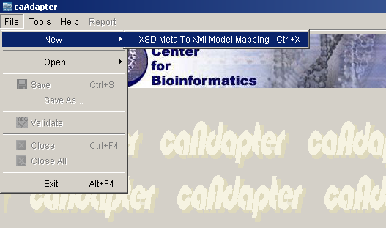
Figure 2-1 New XSD Meta to XMI Model Mapping Menu Item

- The system will display the XSD to XMI Mapping screen (Figure 2-2).

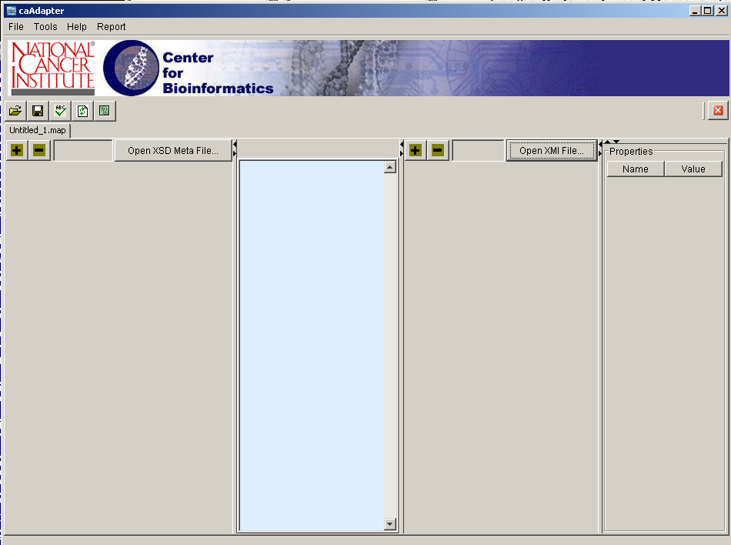
Figure 2-2 XSD to XMI mapping screen
- Click the Open XSD Meta File button to locate the source XSD data file (Figure 2-3).

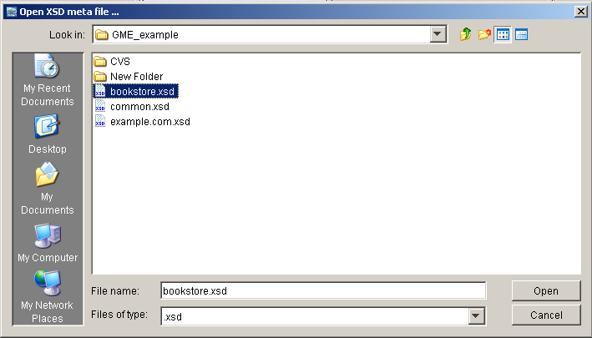
Figure 2-3 Locate the Source XSD data file
- Once the file is selected, caAdapter will display the selected XSD file metadata in a tree structure in the left panel of the mapping tool (Figure 2-4).

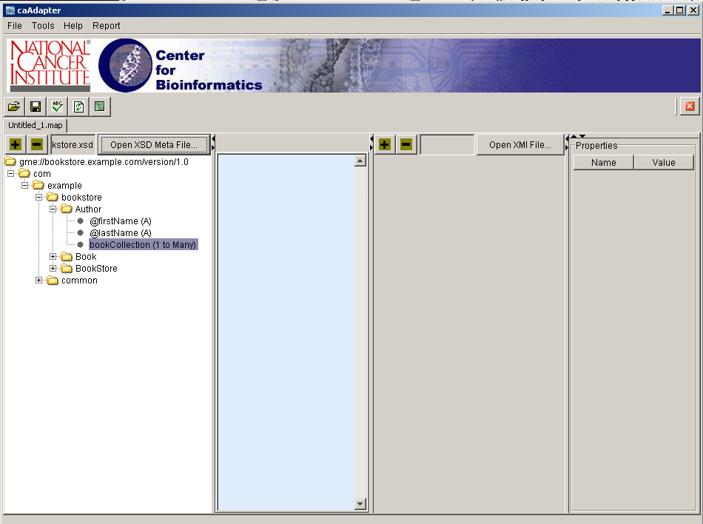
Figure 2-4 XSD metadata loaded into caAdapter
- Click Open XMI File to load the Object Model file (Figure 2-5). Once the XMI is selected, it will be displayed in the right panel of the mapping tool.
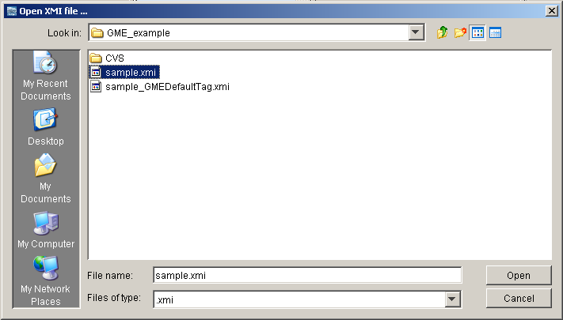
Figure 2-5 Locate the XMI data file
- Once valid XMI and XSD files are selected, the system will display them in the right and left panels of the mapping tool (Figure 2-6).

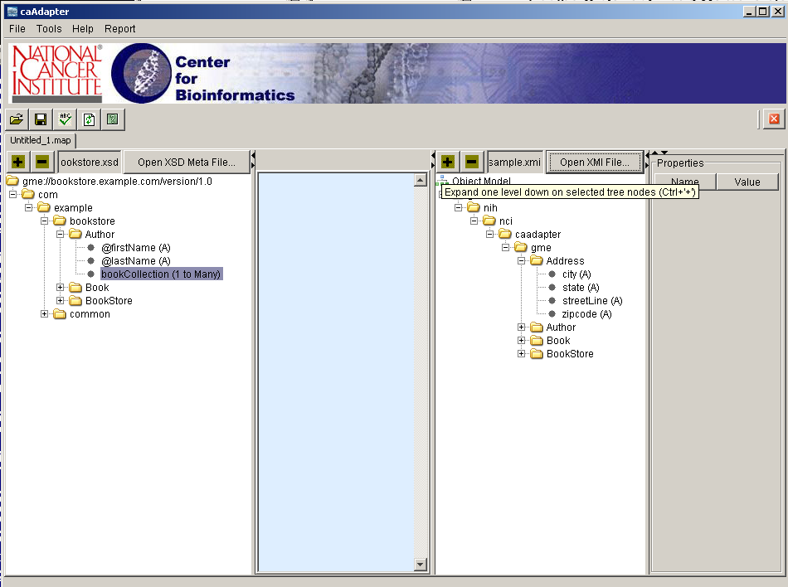
Figure 2-6 Loaded XSD and XMI data in the mapping tool
- Once the source and destination files have been selected and displayed in the mapping tool, the user is now ready to perform the mapping using drag-and-drop mechanism (Figure 2-7).

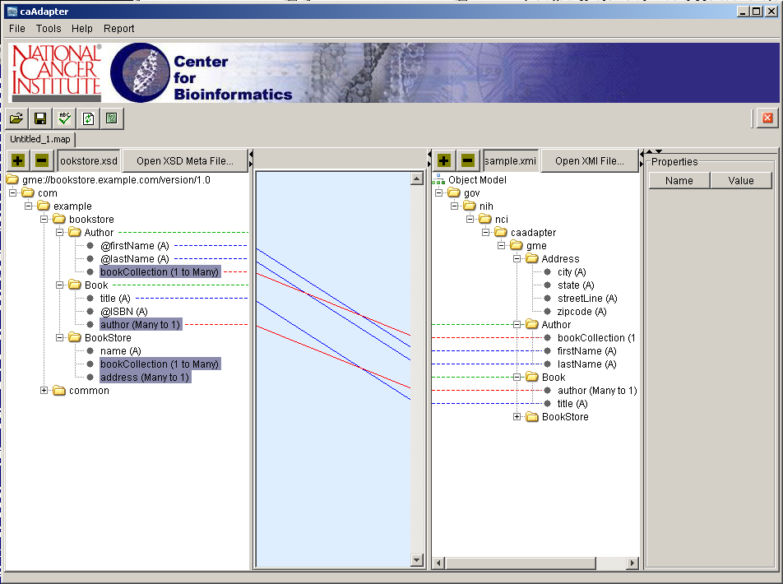
Figure 2-7 Example mappings between XSD and XMI data
As the user performs the mapping between the elements, caAdapter creates the corresponding GME tags and places them in the XMI file. Although caAdapter creates GME tags at the Project, Package, Class, Attribute, and Association levels, the user needs only map at attributes and associations levels. caAdapter will automatically create the corresponding Class, Package and Project tags.

To delete a specific mapping, highlight the mapping line, click the right mouse button, then select Delete. This will remove the line from the mapping tool, and delete the corresponding GME tag(s) from the XMI file.

To delete all mappings, highlight any mapping line, click the right mouse button, then select “delete all”. This will remove all lines from the mapping tool, and delete all GME tags from the XMI file.

Note: This version of the GME Module uses the following basic mapping rules. Additional mapping rules will be implemented in later versions.
- The user may not map a single attribute from the XSD file to more than one attribute in the XMI file. (i.e. one-to-many attribute mapping is illegal)
- The user may not map a single association, from the XSD file to more than one association in the XMI file. (i.e. one-to-many association mapping is illegal)
- The user may not map more than one attribute from the XSD file to a single attribute in the XMI file. (i.e. many-to-one attribute mapping is illegal)
- The user may not map more than one association from the XSD file to a single association in the XMI file. (i.e. many-to-one association mapping is illegal)

Glossary
The following table contains a list of terms used in this document, with accompanying definitions.

Term | Definition
EA | Enterprise Architect. UML Modeling Tool.
GME | Global Model Exchange
NCI CBIIT | National Cancer Institute Center for Biomedical Informatics and Information Technology
UML | Unified Modeling Language
XMI | XML Metadata Interchange
XML | Extensible Markup Language
XSD | XML Schema Definition

Index

EA 6
GME 4, 6, 7, 8, 12, 13
GME Tags 12
Mapping Tool 6, 10, 11, 12
NCI CBIIT 3, 4, 13
UML 6, 13
XMI 8, 9, 10, 11, 12, 13
XSD 6, 8, 9, 10, 11, 12, 13

